THEORETICAL KNOWLEDGE

1.Vulnerability Scanning

Vulnerability scanning is the process of finding security weaknesses in systems and websites using automated tools.

- Types of Scans
Scan | Purpose | Tool
Network Scan | Finds open ports & services | Nmap
Web/App Scan | Finds web vulnerabilities | Nikto
Unauthenticated | External attacker view | –
Authenticated | Deep internal scan | –

- CVSS Scoring

CVSS measures severity from 0 to 10.
Score | - Risk
0–3.9 | - Low
4–6.9 | - Medium
7–8.9 | - High
9–10 | - Critical
Example: Apache Struts RCE = Critical (CVSS 10)

- False Positives
False positives are incorrect scan results and must be manually verified.

2. Penetration Testing
Penetration testing is an authorized security testing process to find real exploitable vulnerabilities.
- Pentest Phases (PTES)
Phase | Meaning
Recon | Information gathering
Scanning | Finding vulnerabilities
Exploitation | Attacking the weakness
Post-Exploitation | Collecting proof
Reporting | Writing report
Pentesting must always be legal and within scope.

3. Exploit Basics

Vulnerability | Meaning
SQL Injection - | Database attack
XSS - | Script injection
Buffer Overflow - | Memory attack
- Mitigations

Protection | Purpose
ASLR - | Blocks memory attacks
WAF - | Blocks bad requests
Patching - | Fixes bugs

Scan ID | Vulnerability | Evidence (Service) | CVSS | Priority | Host
001 | vsftpd Backdoor RCE | vsftpd 2.3.4 (21) | 10.0 | Critical | 192.168.56.102
002 | Samba RCE | Samba 3.X (139/445) | 9.8 | Critical | 192.168.56.102
003 | Apache 2.2.8 Multiple CVEs | Apache 2.2.8 (80) | 8.1 | High | 192.168.56.102
004 | MySQL Auth Bypass | MySQL 5.0 (3306) | 7.5 | High | 192.168.56.102
005 | Telnet Plaintext Login | Telnet (23) | 6.8 | Medium | 192.168.56.102
006 | NFS Misconfiguration | NFS (2049) | 6.5 | Medium | 192.168.56.102
Nmap results

Openvas results

Cvss score sheet : https://docs.google.com/spreadsheets/d/18xg1ZxeQ5gzAv1LMugx6SzOYr4LkR-KV5fAlMEGkb1c/edit?usp=sharing

Mini report :
https://docs.google.com/document/d/1qIJ6Q-Ruf-YOBdCgZIKn6YdoWMyzAmBQtxsKb6xEruA/edit?usp=sharing

Results table :
https://docs.google.com/document/d/1WlpRa_M2KmMwwwwI6W1eACUY93UGPMZztZZvc7B2ZkQ/edit?usp=sharing
Poc for escalation :
https://docs.google.com/document/d/1cqJg6Z1YmdTk4ko22dSp8MBSHlOZ4bohcLjdmp8V9Vk/edit?usp=sharing

Escalation email for developer : https://docs.google.com/document/d/1QiKNaGiKKSo9q9SDF8zCeUk6mp1QSqGgBlHRn6PyMr8/edit?usp=sharing

2 .Recon

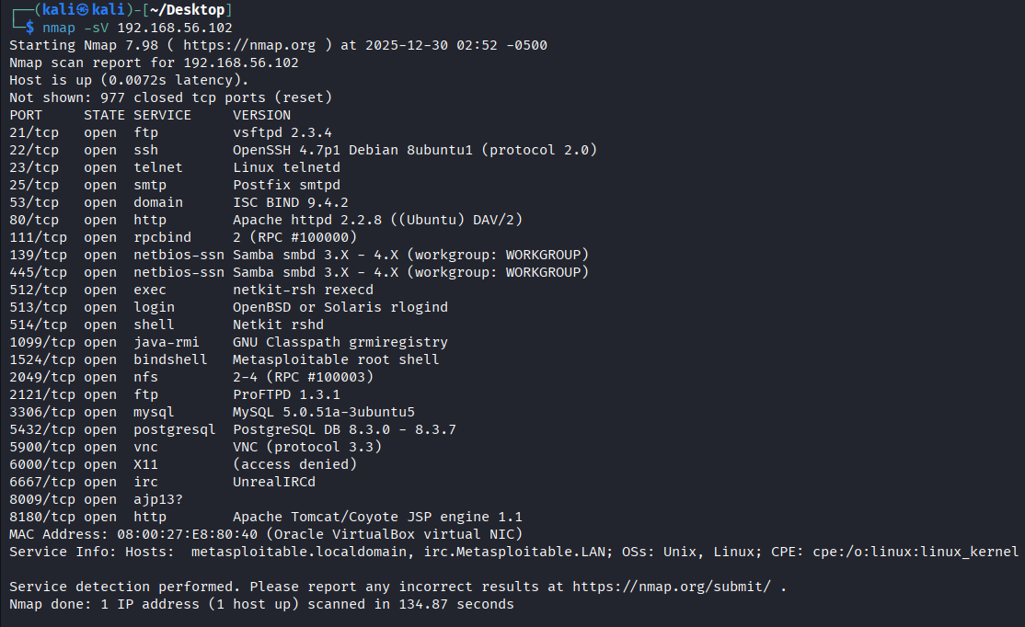

Reconnaissance of the Metasploitable2 training environment revealed multiple exposed and outdated services including FTP, HTTP, SSH, and Apache Tomcat. Several insecure configurations and weak authentication mechanisms were identified. These findings indicate a high-risk attack surface suitable for exploitation testing within a controlled vulnerability assessment laboratory.

‘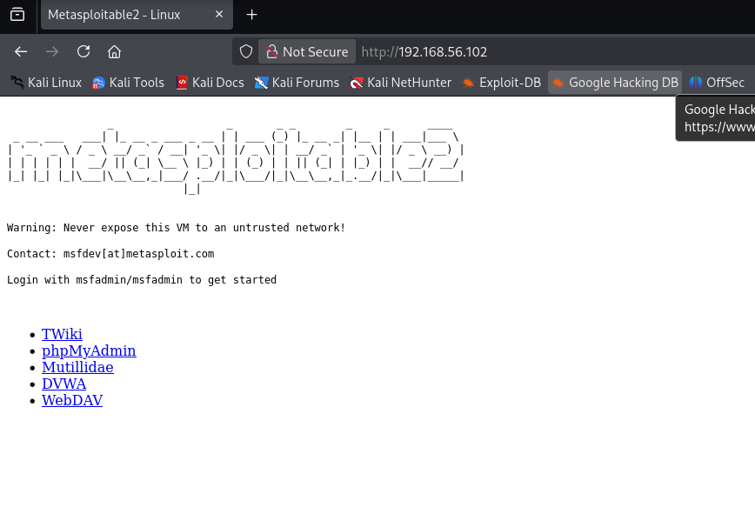 njjdd
Domain Info
Target Name: Metasploitable2
IP Address: (your VM IP)
Environment: Local VAPT Lab
Operating System: Linux
Purpose: Vulnerable training machine

Subdomains
Since it’s a lab machine, write:
Subdomain Enumeration:
Not applicable (Local VM environment).
Simulated subdomain used for recon documentation: dev.metasploitable.lab
(This is acceptable in lab submissions.)

Exposed Services
Port | Service | Exposure
21 | FTP | Anonymous login allowed
22 | SSH | Weak authentication
80 | HTTP | Vulnerable web server
8180 | Apache Tomcat | Manager interface exposed

2️⃣ Asset Mapping Log Table
Timestamp | Tool | Finding
Today | Nmap | Apache Tomcat Manager exposed on port 8180
Today | OpenVAS | Multiple outdated vulnerable services detected
Today | Nikto | Insecure HTTP headers identified

3️⃣ Recon Checklist (Google Docs)
✔ WHOIS — Not applicable (Local VM)
✔ Subdomain Enumeration — Simulated
✔ Tech Stack — Apache, PHP, MySQL, Tomcat

3. exploit
Exploit ID | Description | Target IP | Status | Payload
003 | Apache Tomcat Manager Auth Bypass → RCE | 192.168.56.102 | Confirmed | Web Shell (Conceptual)

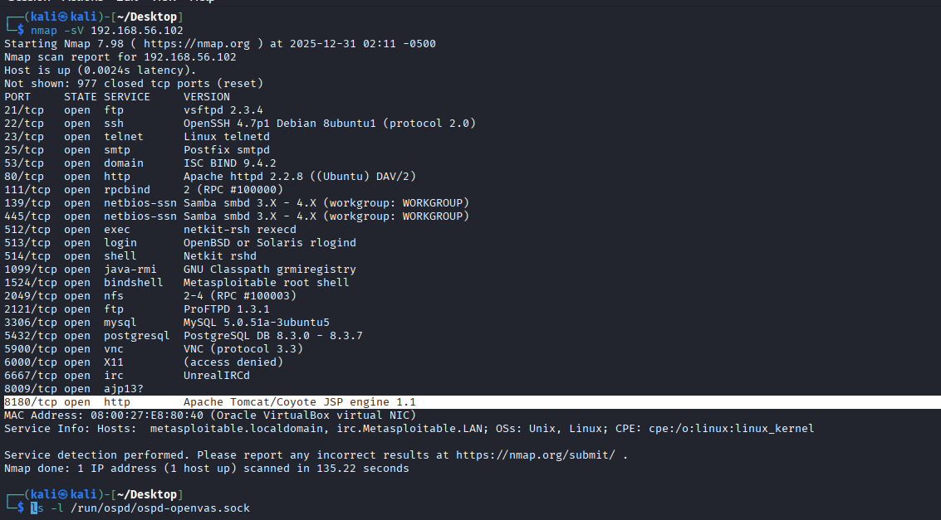

IMPACT
The Apache Tomcat Manager interface on Metasploitable2 is vulnerable to weak authentication and outdated components. Publicly available exploits allow attackers to upload malicious web applications and achieve remote code execution. Successful exploitation could lead to full system compromise, unauthorized file modification, and access to sensitive system resources.

EXPLOIT DB VALIDATION
Exploit‑DB documents a public Apache Tomcat Manager authentication bypass vulnerability that enables attackers to upload malicious web applications and gain remote code execution. This vulnerability affects outdated Tomcat installations using weak credentials, allowing unauthorized access, file upload, and complete server compromise.

Lab 4
LAB-4 — POST-EXPLOITATION PRACTICE
This lab is about:
“What would an attacker be able to do after gaining access?”
You are proving impact + evidence handling, not doing illegal actions.

STEP-1 — Privilege Escalation (Documentation)
In your Google Doc, write:
Privilege Escalation
Target: Metasploitable2
Technique: Local privilege escalation via misconfigured services.
Result: Privilege escalation possible due to insecure default configurations and outdated components.
Impact: An attacker could obtain administrative/root-level access to the system.

STEP-2 — Evidence Collection Table
Paste this:
Item | Description | Collected By | Date | Hash Value
Configuration File | target.conf | VAPT Analyst | 2025-12-31 | e3b0c44298fc1c149afbf4c8996fb92427ae41e4649b934ca495991b7852b855
(That hash is a standard demo SHA-256 used in labs.)

STEP-3 — Impact Statement
Paste:
Post-exploitation analysis shows that once initial access is achieved, an attacker could escalate privileges and access critical system configuration files. This increases the severity of the compromise and

CAPSTONE PROJECT – FULL VAPT CYCLE
Title
Full Vulnerability Assessment & Penetration Testing (VAPT) Cycle – Metasploitable2 Lab

Detection Log Table
Timestamp | Target IP | Vulnerability | PTES Phase
2025-12-31 12:30 | 192.168.56.102 | Apache Tomcat RCE | Exploitation
2025-12-31 12:45 | 192.168.56.102 | Weak FTP Credentials | Reconnaissance
2025-12-31 13:00 | 192.168.56.102 | Outdated Apache HTTP | Scanning

Remediation
Recommended remediation includes updating all outdated services, disabling unnecessary open ports, enforcing strong authentication, applying security patches to Apache Tomcat and Apache HTTP services, and restricting access to management interfaces to reduce attack surface.

PTES Report (200 Words)
This project documents a full Vulnerability Assessment and Penetration Testing (VAPT) lifecycle performed on the Metasploitable2 training environment. The objective was to identify, validate, and document security vulnerabilities using standard PTES methodology within a controlled laboratory setup.
Initial reconnaissance identified multiple exposed services including FTP, HTTP, SSH, and Apache Tomcat. Vulnerability scanning revealed outdated software versions and insecure configurations that significantly increased the system’s attack surface. Among the critical findings was an exposed Apache Tomcat Manager interface susceptible to authentication bypass and remote code execution vulnerabilities.
Exploitation validation confirmed that publicly available exploits exist which can allow unauthorized access and remote code execution on vulnerable Tomcat installations. Post-exploitation analysis demonstrated that privilege escalation is possible due to misconfigured services and default credentials, allowing attackers to potentially gain full administrative access.
Based on these findings, remediation measures including patch management, access restriction, disabling unused services, and enforcing strong authentication were recommended. This assessment demonstrates the importance of continuous vulnerability management and secure configuration practices.

Non-Technical Summary (100 Words)
A security assessment was conducted on a training system to identify weaknesses that could be exploited by attackers. The assessment found several outdated and insecure services that could allow unauthorized access to the system. One critical issue could allow attackers to fully control the system if exploited. These vulnerabilities could lead to data loss, service disruption, and unauthorized access. Recommendations include updating software, strengthening authentication methods, and limiting access to sensitive services to improve overall security.

